Information Sheet: YWCA Halifax
Before and After School Program at
Rockingstone Heights School

What is the Before and After School Program (BAP)?
When the Province of Nova Scotia introduced the universal pre-primary program for four-year-olds, it was recognized that there was a gap for families who needed care before and after the regularly scheduled school day. These pre-primary children, many of whom were previously in licensed childcare settings, typically had care available from 7:30am to 5:30pm. As a result, the Province introduced the BAP in schools that did not already have options for this age group.

The focus of the BAP is physical education, healthy development, and play-based learning. Similar to licensed childcare settings, all BAP staff are screened and experienced in providing care for young children.

Fundamentally, the BAP is an important partner program to the provincial pre-primary program, enabling young elementary aged children to be enrolled with minimal disruption for families.

When does the BAP run?
YWCA Halifax’s BAP runs in Rockingstone on all regular school days when classes are in session. We operate in two shifts: 7:30-9:00am and 2:30-5:30pm. Staff typically arrive a minimum of 15 minutes early to prepare for the arrival of children and may stay 15 minutes after for clean-up and preparing for the next day.

How did the YWCA come to Rockingstone?
YWCA Halifax has been operating a licensed childcare centre in Spryfield for ten years. We are also the oldest provider of licensed care in the province and have a long history of providing support for diverse families from various backgrounds.

Because of our connection to Spryfield, our relationships with families with young children, and our experience in providing care for young children, the Province of Nova Scotia invited YWCA Halifax to apply to be the BAP provider at Rockingstone. We were excited and happy to do so.

Who are the BAP staff?
The YWCA BAP team includes a strong and experienced leadership group and staff team on site. Our staff have years of training in early childhood education and are committed to the inclusion of diverse children and families with various needs.

Kerri Johnson: Director of Early Learning & Childcare
Kerri has over 30 years as an ECE and 10+ years as Director. She is a member of the Nova Scotia Curriculum Framework Committee for early childhood education, teaching faculty at NSCC, and a leader in the development of NSCC’s Africentric curriculum for ECE students.

Krista Maynard: Assistant Director of Early Learning & Childcare
Krista has over 25 years as an ECE and has been in leadership roles at the YWCA for more than five years. She is currently the lead for both YWCA BAP locations.
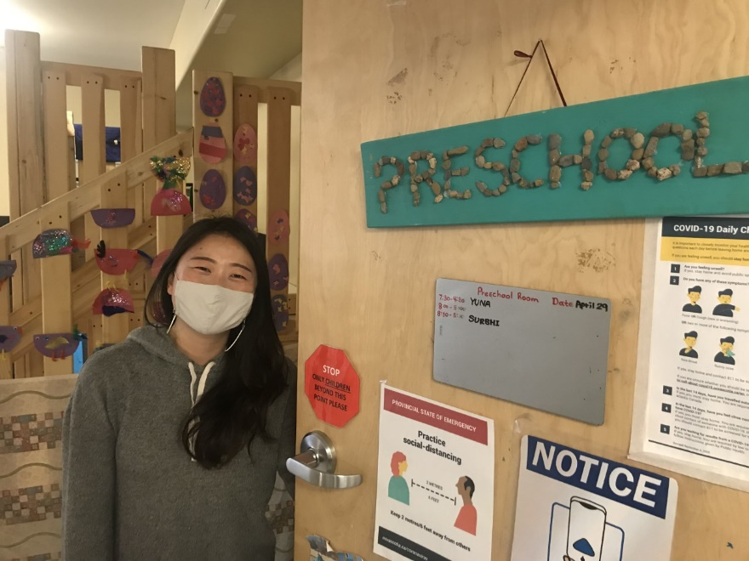
Yuna Lee: Inclusion Coordinator
Yuna has been an ECE for more than eight years and currently serves as YWCA’s Inclusion Coordinator, ensuring that children with special needs have everything they need to be successful in our programs.

Amanda Marriott: BAP Lead Educator
Amanda has 5 years of experience working as an ECE. She has obtained her School Age Approval Level through the Department of Education, Early Years branch. Amada has been the BAP Lead Educator since 2020 and completes all required PD hours required annually.
Justine Alchom: BAP Assistant
Justine has 3 years of experience as a Before and After School Educator, starting with the Excel program in 2019 before joining the YWCA’s BAP team in 2020. Justine continues to complete all required PD hours required annually.

Where does the BAP happen?
Although we are not restricted to school property, the BAP takes place on school property. We share the classroom spaces with the pre-primary program even though not all the children are pre-primary students. We also share the school playground, bathrooms, parking spaces, gym with the school.

What are the roles and responsibilities of YWCA Halifax?
The BAP staff work in schools and form part of the school community. Children in the BAP are not limited to pre-primary students, although priority is given them. Families who enrol their children with YWCA Halifax for the BAP consent to leaving their children in our care and complete the required consents and paperwork. In short, we are responsible for the BAP children when they are in our program, even though the program is taking place on school property or in the pre-primary classroom. Family-centred care is a hallmark of our work.

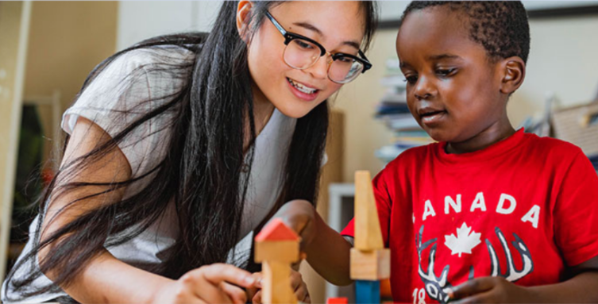

What makes the program successful?
The BAP’s success hinges on many key factors:
- Qualified and competent staff with appropriate supports;
- Positive relationships with families;
- Excellent relationships with everyone in the school community, including the pre-primary program and school teaching staff and administrative team;
- Access to appropriate facilities to learn, play, and grow; and,
- A commitment to teamwork, communication, and continuous learning.

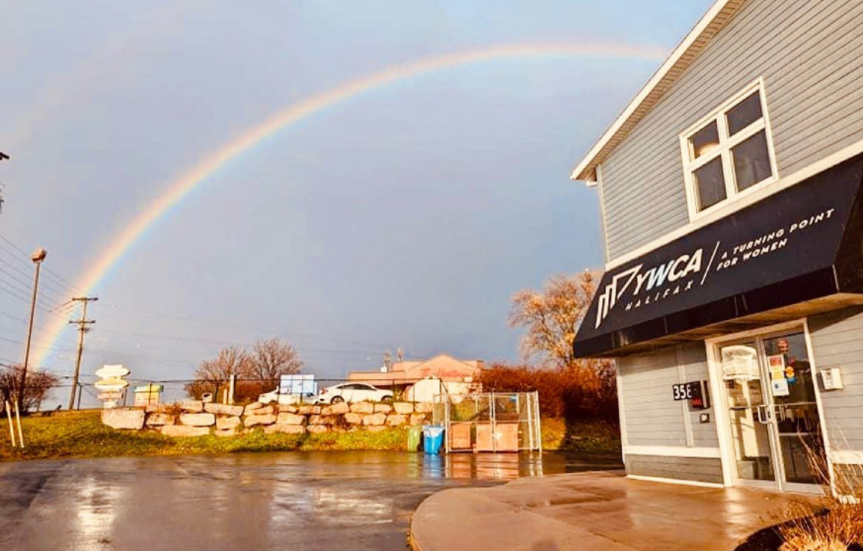

How can others support the BAP?
We love it when we can support one another! Share information about the BAP, including our contact information, with families who need before and after school care for their children. Treat the BAP staff as welcome members of the school community and work with us when children need supports to thrive in the BAP and in their regular classroom.

Who do you talk to for more information or about the BAP?
All communications about the program should go to:
Krista Maynard, Assistant Director of Early Learning & Childcare
Phone 902-209-1848
k.maynard@ywcahalifax.com

Contact Krista about:
- Families that are looking to enrol their children in the BAP;
- Staff who have questions about the program; and,
- Anyone who may have any comments about the program.

We take all feedback seriously and ask that communications be directed to Krista and not on-site staff. We are committed to ensuring accuracy, responsiveness, and positive growth together.

